

**Preliminary report**



**Development of a C++ based user-interface for a plasma simulation tool**



**Author: Zhang, Junming (ID: 201138928)**

**Project Supervisor: Dr Mark Bowden**

**Project Assessor: Dr Kirsty McKay**

**Department of Electrical Engineering and Electronics**

**14 October 2016**

**Declaration of academic integrity**

**I confirm that I have read and understood the University’s Academic Integrity Policy.**

**I confirm that I have acted honestly, ethically and professionally in conduct leading to assessment for the programme of study.**

**I confirm that I have not copied material from another source nor committed plagiarism nor fabricated, falsified or embellished data when completing the attached piece of work. I confirm that I have not copied material from another source, nor colluded with any other student in the preparation and production of this work.**

**SIGNATURE……………………………………………………………………………………… DATE ……………………………………………………………………………………….**

# Abstract

蓝色不确定，红色确定

An existing microplasmas simulation tool which developed by the technological plasma team will generate numerous (considerable) output data in various formats. Thus (Therefore,) a user-friendly-interface (user-friendly interface) is needed by relevant researchers and industry users.

This report is aimed to (at, be aimed to是相似的，或者改成 the aim of this report is ) describe the preliminary development procedures of this user-friendly interface and it (指代不明，指的是report还是procedures。我觉得用This report或者the procedure) will （不能用被动的话可以用include，就不加will了）be divided into 6 (six) parts which are project description, methodology, project plan, project rationale with (and?) industrial relevance（the relevance of industry/manufactory）, literature review and the working result(results) in the first three weeks.

The future work of this project will (perform 加一个动词，缺少动词，regrading是关于，所以不对) in terms of （according to应该也可以）the project plan in continuing research.

Contents

Abstract 1

1. Introduction 3

2. Project Description 4

2.1 Problem statements 4

2.2 Project overview 7

3. Methodology 8

3.1 Tools 8

3.1.1 C++ based software developing tools 8

3.2 Software Development Process 8

3.2.1 Software requirements 8

3.2.2 Design 10

4. Project Plan 11

5. Project Rationale and Industrial Relevance 12

6. Literature Review 13

7. Results 14

7.1 Preliminary research of plasma 14

7.1.1 Plasma and Micro Discharge 2D(md2d) model 14

7.2 Preliminary developing of software 16

7.2.1 Rapid loading text files function 16

8. Conclusion 18

References List 19

Appendices 20

Appendix 1. The specification report forms 20

Appendix 2. A Gantt chart preferable (啥意思？更好的？不对吧) produced by MS project 24

Appendix 3. The risk assessment forms 25

Appendix 4. Ethical approval questionnaire 29

# Introduction

This preliminary report will be divided into 6(six) main parts (主动：it will divide this report into six main parts):

First is the project description. The overview, aims and objectives of this project will be mentioned and then the general ways to realize these aims(重复，purposes) will be described （it will describe the general ways about how to realise these purposes）.

(The) Second part is the methodology. The specific tools and technological processes of this project will be explained. (主动语态还能换一下句式，前面的句号去掉include the explanation of the specific tools and technological processes)

（The）Third part is project plan and Gantt chart. This project is combined from(with) a large amounts of specific tasks with duty cycle（主动语态 a large amounts of specific tasks with duty cycle constitute this project） and then it (these tasks)will be used to generate the Gantt chart for managing the task progress (重复，the procedure of project).

After that is (the part of, 不然就把is 改成are, abstract 你写的是project rationale with industrial relevance（the relevance of industry/manufactory）如果是with 就用is)project rationale and industrial relevance. The evaluation of this project and the research interests of project supervisor will be used to analysis this project and the relationship with industry. (In addition, the relationship between this project and industry also need to be analysed)

And then is the literature review. The relevant research results of other people will be browsed and displayed as (the) reference list(s).

Last part is the result. Preliminary research result of this project in the first three weeks will be introduced.

# Project Description

## 2.1 Problem statements

The Technological Plasma Group has developed a simulation too for microplasmas which called Plasimo. Large amount of output files will be generated through simulated these models of plasma. (It has been generated a large amount of output files through simulated these models of plasma)

Plasimo 5.0 developer version and the Micro Discharge 2D (md2d) model of plasma will be applied on this project. The running process of this simulated tool is (will) shown as (in) Figure 1.

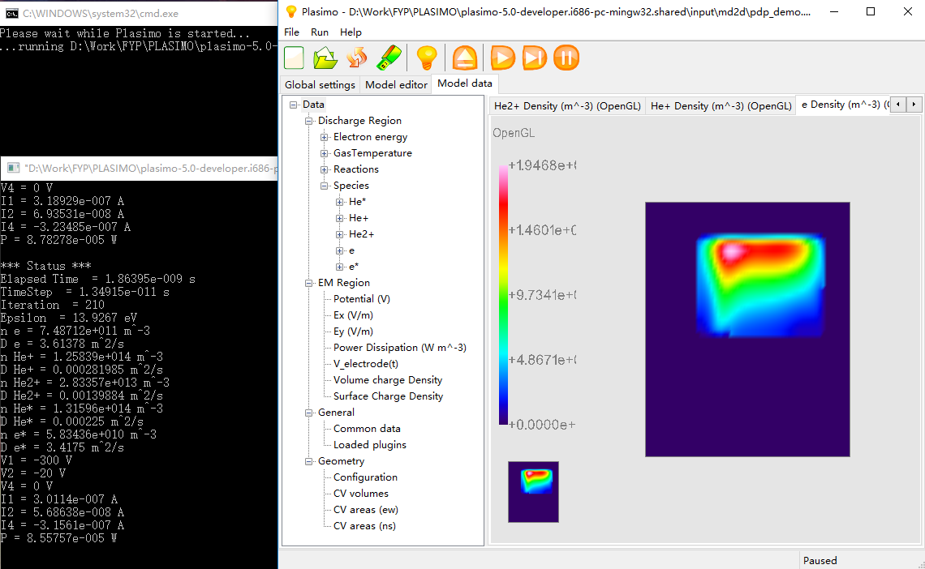

Figure 1. Running process of Plasimo 5.0 with md2d model

After finished the simulated process, (it will generate a) large amount of output files ~~will be generated~~ as text and (the) out (output) formats which is (will) show as (in) Figure 2.

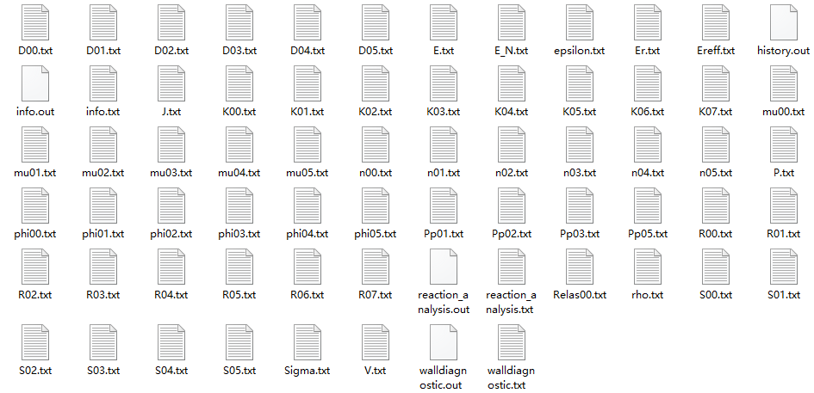

Figure 2. Output files of md2d model simulation

Lots of information of simulated plasma are stored ~~as specified~~ in these files (in detail). The explanation of each files (file) will be shown in Table 1[1].

|  |  |
| --- | --- |
| n00.txt | electron energy density [J m-3] |
| phi00.txt | electron energy flux density [W m-2] |
| S00.txt | electron energy source [W m-3] |
| D00.txt | electron energy diffusion coefficient [W m2] |
| mu00.txt | electron energy mobility coefficient [J m2 V-1 s-1] |
| Relas00.txt | rate of electron energy loss from elastic collisions [W m-3] |
| epsilon.txt | mean electron energy [J] |
| n01.txt | density for species 1 [m-3] |
| S01.txt | source for species 1 [m-3 s-1] |
| D01.txt | diffusion for species 1 [m2 s-1] |
| mu01.txt | mobility for species 1 [m2 V-1 s-1] |
| phi01.txt | flux for species 1 [m-2 s-1] |
| R00.txt | reaction rate for reaction 1 [m-3 s-1] |
| K00.txt | reaction rate coefficient for reaction 1 [m3 s-1] |
| Pp01.txt | power dissipation for species 1 [W m-3] |
| P.txt | dissipated power density [W m-3] |
| J.txt | current density [C s-1 m-3] |
| V.txt | potential [V] |
| E.txt | electric field [V m-1] |
| Er.txt | reduced electric field E/p [V m-1 Pa-1] |
| E_N.txt | reduced electric field E/N [V m2] |
| rho.txt | volume charge density [C m-3] |
| sigma.txt | surface charge density [C m-2] |
| info.txt | the averaged values written with the user-specified frequency |
| info.out | the averaged values |
| history.out | gives the calculated variables as a function of time |

Table 1. The explanation of each simulated output files from plasimo user guild

For plasma model md2d, (it need simulation for a long time) a long simulated time is needed to run the md2d model in the plasimo. In addition, there are total 68 output files with 32.9 MB data and different files represent different data of plasma as shown in Table 1. Moreover, a number of these data are useless to them. (it contain a number of useless data.) thus (Hence,) researchers and industry users are complicated to read these data.

## 2.2 Project overview

According to the problem statements, a software with user-friendly interface is needed to developing. Therefore, the aim of this project is to develop a practical C++ based user-interface to help researchers and industry users obtain significant output data effectively.

This project could be divided into two main objectives:

* First is research of plasma to select useful data from various output data because the significant data are needed to pick at the beginning to reduce the workload of programming. Hence, background reading and research for plasma discharges will be involved as an initial phase of this project. (the initial phase of this project will include background reading and plasma discharges researching)
* Second and the key aspect of this project is develop a widely accessible user-interface to help researchers and industry users. The ability of developing interface by using C++ based tools should be trained.

In order to finish this project within 20 weeks, it needs developer working by combined research work and programming skill together. (it needs developer working through combined research work with programming skill). Meanwhile, the report and presentation of this project should be prepared. More detail about how to realize this project will be discussed in the Methodology part. (and then it will discuss more detail about how to realise this project in the Methodology part.)

# Methodology

## Tools

### 3.1.1 C++ based software developing tools

The requirement of this project is under C++ developing environment. (There are three)3 main tools will be used to build this user-interface.

#### 3.1.1.1 Microsoft Visual Studio Community 2013

Visual Studio is the most popular integrated development environment on Windows. It will be used for the major developing tool in this project.

#### 3.1.1.2 Qt 5.7.0

Qt is a framework of cross-platform C++ graphical user interface (GUI) application development. It contains the fundamental technology of GUI which is used to render the interface [2].

#### 3.1.1.3 openGL

Open Graphics Library (OpenGL) is the most widely 2D and 3D Application Program Interface (API). It could be applied in lots of platforms such as Window, Linux and MacOS.

## Software Development Process

### 3.2.1 Software requirements

This program is used to display required data by processing considerable text files and it should be used to select significant data of plasma to researchers and industry users.

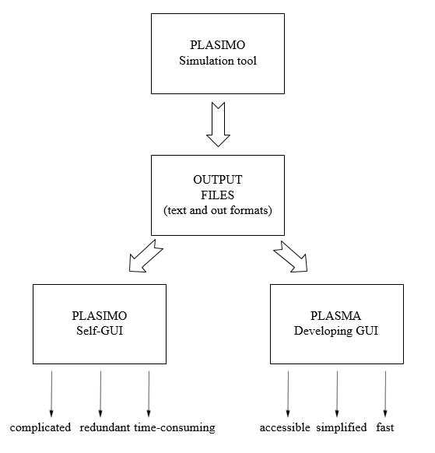

Figure 3. The general analysis of this project

According to analysis the characters of this original GUI in Plasimo, it could find it is complicated because new users are hard to run this software without handbook. At the same time, redundant output data will be generated through the simulated process, researchers and users cannot find useful data efficient. For m2de model, it cost 10 minutes to run simulation. However, there still has other models of plasma are more time-consuming.

In order to solve these problems, it could find the software requirements are an accessible, simplified and fast GUI to support useful data to users. This analysis process is shown as Figure 3 and the design process of this project will follow this analysis.

### 3.2.2 Design

In order to realize requirements of this software, accessible, simplified and fast will be consider as the key points of the design process.

#### 3.2.2.1 User-interface building

In order to develop an accessible user-interface, the key aspect is it should obey the Eight Golden Rules of Interface design [3].

* Strive for consistency
* Cater to universal usability
* Offer informative feedback
* Design dialogs to yield closure
* Prevent errors
* Permit easy reversal of actions
* Support internal locus of control
* Reduce short-term memory load

In addition, research interfaces of different software especially research-based software are significant.

The soul of this project is user-interface, thus it needs to spend more time to compare advantages and disadvantages of different interfaces in continuing research.

#### 3.2.2.2 3D graphical display function

For technology users, the output simulated data of plasma should be displayed intuitionistic. Therefore, 3D graphical model could be treated as a simplified and intuitionistic way to research plasma. Users could observe the changing process of particular plasma model.

#### 3.2.2.3 Rapid loading text files function

Excellent reasoned time of a software should be considered as an important standard. Numerous output data will be generated by md2d plasma simulation and other models of plasmas may spend longer time to obtain results. In addition, there are 68 output files of one simulated plasma, thus the rapid text files loading function is needed to researching and developing fast interface.

# Project Plan

4.1 FYP

4.1.1) Preparatory Work

4.1.1.1) Obtain plasma simulation tool and relevant reading materials

4.1.2) Research Work

4.1.2.1) Weekly background reading for plasma discharges.

4.1.2.2) Investigating significant data in numerous output file.

4.1.2.3) Investigating Interface of learning, researching and factory software.

4.1.2.4) Literature review.

4.1.2.4) Learning of corresponding software include C++ based visual studio, openGL and Qt.

4.1.3) Developing Work

4.1.3.1) Write software requirements

4.1.3.1.1) software specifications

4.1.3.1.2) software analysis

4.1.3.2) Design

4.1.3.2.1) Rapid loading text files function developing.

4.1.3.2.2) 3D graphical model displayed function developing.

4.1.3.2.3) Intuitive user-interface developing.

4.1.3.3) Testing and improving

4.1.3.3.1) Program test and debug.

4.1.3.3.2) Development methodology.

4.1.4) Report Work

4.1.4.1) Writing project specification report form.

4.1.4.2) Writing Preliminary report.

4.1.4.3) Weekly virtual log book.

4.1.4.4) Preparing presentation.

4.1.4.5) Creating poster.

4.1.4.6) Writing final report.

*The complicated project plan will be shown in Appendix 2 with the Gantt chart.*

# Project Rationale and Industrial Relevance

In this project, the major areas related are computer science and physical, which are both significant branches of human scientific and technological development. In addition, the relationship of these two areas and EEE are not closely. Therefore, this is a more challenging opportunity to test the learning ability of new areas as a EEE undergraduate.

For the continuing development, high value of this project could be created because there are many applications on plasma.

For example, microplasmas for biomedical is an important application. The plasma needle could be used to product reactive species such as excited molecules, radicals and ions [4]. In this case, the properties of the plasma needle can be displayed and investigated in simulation tool which is shown as Figure 4.

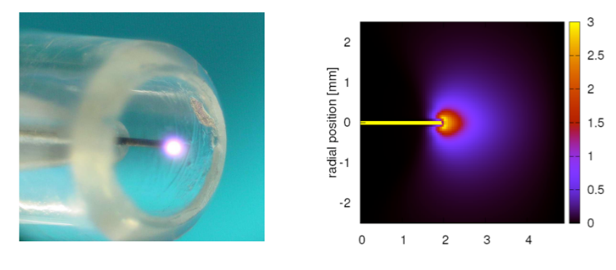

Figure 4. Simulation of the plasma needle

Source: Numerical description of discharge characteristics of the plasma needle

# Literature Review

At the preliminary stage, 3 literatures related to this project has been found through the university library database. Two of them are related to web-based user-interface and the remaining one is related to software interface developing of plasma tools.

To better understand the characters of user-interface design, R.R. Zhang, B.J. Xiao, Q.P. Yuan, F. Yang, Y. Zhang, R.D. Johnson, B.G. Penaflor (2014) illustrates the clearly design process of GUI, they have excellent workflow to deliver their ideas. However, the completed interface is not adequate quality as their design process. M. Emoto, S. Murakami, M. Yoshida, H. Funaba and Y. Nagayama (2007) developed neat interface which could display the data of plasma into formulas and line charts. S. Anett, L. Heike, S. Jörg (2007) described the detailed design process of GUI and the most impressive idea is give the user specialized tools for specific tasks within the control system.

For summarizing these 3 literatures, web-based interfaces are developed by JavaScript, but the concept of GUI design process is worth to study, both clear explanations and flow charts are needed to display the interface. Moreover, thinking more of users is the most important factor to develop a wonderful GUI.

**Literature reviews appendix**

* M. Emoto, S. Murakami, M. Yoshida, H. Funaba and Y. Nagayama., " Web interface for plasma analysis codes", *J. Appl. Phys.* vol. 83, no.2-3, pp. 453-457, April 2008, DOI: 10.1016/j.fusengdes.2007.10.008
* S. Anett, L. Heike, S. Jörg, " User control interface for W7-X plasma operation", *J. Appl. Phys.* 2007, DOI: 10.1016/j.fusengdes.2007.05.052
* R.R. Zhang, B.J. Xiao, Q.P. Yuan, F. Yang, Y. Zhang, R.D. Johnson, B.G. Penaflor, " The web-based user interface for EAST plasma control system", *J. Appl. Phys.* February 2014, DOI: 10.1016/j.fusengdes.2014.02.070

# Results

Plasma is a new area of EEE student, thus this project contains two main parts which are deep learning about plasma and user-interface developing.

At the preliminary stage, research basic properties of plasma and develop specific function are two main result in the first 3 weeks.

## 7.1 Preliminary research of plasma

### 7.1.1 Plasma and Micro Discharge 2D(md2d) model

#### 7.1.1.1 Plasma definition

Plasma is one of the four fundamental states of matter, it is part of ionized gas which consists of electron, ion, free radical, neutral ion and photon.

The general type of plasma will be applied at this project which is shown in Figure 5.

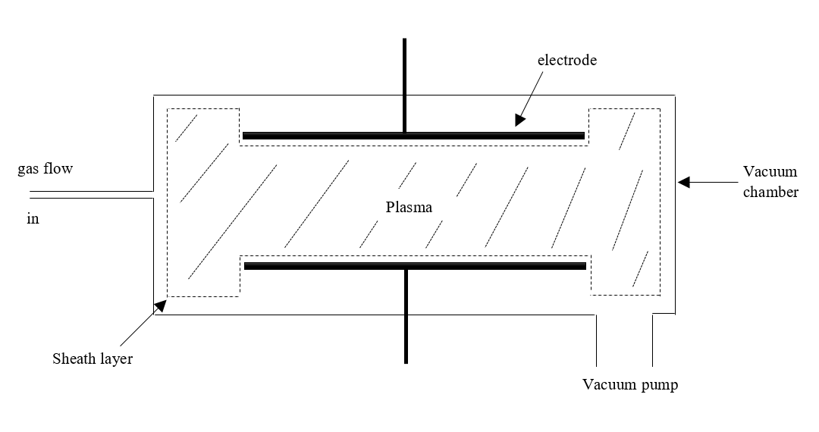

Figure 5. The general image of a plasma

According to figure 5, it could be observed that the general plasma has a vacuum chamber, pump, a gas flow system and electrodes.

In addition, the plasma has various significant features which are:

* Sheath layer
* Different types of particles
* Reactions in the plasma
* Power input and loss of the plasma
* Gas flow into and out of the chamber.

A large amount of output files is generated through the Plasimo simulation tool and the explanation of each output files is shown in Table 1. It described 24 properties of plasma. However, the most basic plasma properties are:

* Gas Density and pressure
* Neutral particle density
* Electron density
* Electron energy and electron temperature
* Ion density
* Plasma potential
* Ionization ratio

#### 7.1.1.2 md2d model definition

Micro Discharge 2D (md2d) is the target model in this project. It is a time dependent model and the function of it is solve particle transport problem in conjunction [5].

## 7.2 Preliminary developing of software

### 7.2.1 Rapid loading text files function

There are 68 text files with 32.9 MB data of simulated md2d model. Moreover, other models of plasma may generate more data, thus to improve the response speed of this software, the stable and fast text load command should be chosen.

For searching on the internet, there are four commands to load data of text file in C++ environment.

In order to test these command, it need to generate a text file with 10000000 random number first, and the different loading command will be used to test the loading time of this files.

Scanf is the normal loading command in C++.

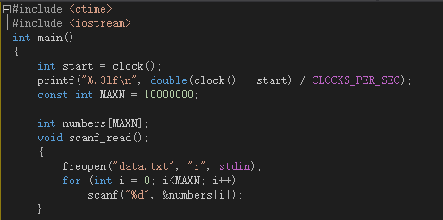

Figure 6. Code of testing scanf command

cin is the most common loading command in C++.

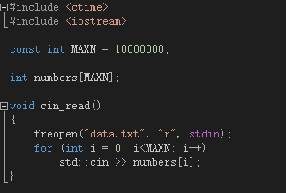

Figure 7. Code of testing cin command

Fread command is used to load all data into one string

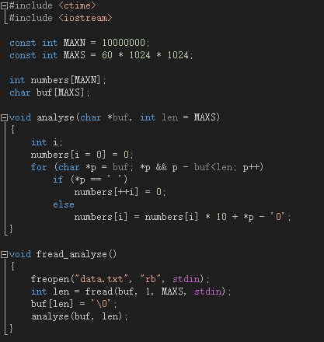

Figure 10. Code of testing fread command

|  |  |
| --- | --- |
| Visual Studio 2013 command | Time (s) |
| scanf | 3.8 |
| cin | 21.6 |
| fread | 0.42 |

Table 2. Testing result of loading command.

According to analysis these result, it could find command fread has the most efficient speed to load files, thus this command will be used as the first choose to loading data.

However, this is only the preliminary test of this function. All test focused on one text file, but there are 68 text files of the simulated output. Thus, the rapid loading text files function still need further development.

# Conclusion

In general, this preliminary report is the initial guild of the Final Year Project which is development of a C++ based user-interface for a plasma simulation tool. It can be divided into six parts include project description, methodology, relevant plan, project rationale, literature review and the result. The aim and objective are developing a user-friendly-interface to help researchers and industry users to investigate plasma effective.

The ability of formulate a project plan and preliminary work are trained through this process. After finish this report, the understanding of the project will be increased, so that it will support convenience to the future development. However, it is still the beginning of this FPY, the details about interface design and relevant programming need more time to investigate.

# References List

[1] The Plasimo Team. (2014 April) IEEE Citation Reference [online]. Available: <https://plasimo.phys.tue.nl/generated-docs/plasimo-5.0.0/misc-docs/user_guide.pdf> (accessed 14th October 2016)

[2] D. Molkentin, “*The Book of Qt 4: The Art of Building Qt Applications*”. San Francisco, USA: No Starch Press, 2007, ISBN-13 978-1593271473

[3] B. Shneiderman. (2010) IEEE Citation Reference [online]. Available: <https://www.cs.umd.edu/users/ben/goldenrules.html> (accessed 14th October 2016)

[4] W.J.M. Brok, M.D. Bowden, J. van Dijk, J.J.A.M. van der Mullen and G.M.W. Kroesen., " Numerical description of discharge characteristics of the plasma needle", *J. Appl. Phys.* vol. 98, 2005, DOI: 10.1063/1.1944218

[5] The Plasimo Team. IEEE Citation Reference [online]. Available: <https://plasimo.phys.tue.nl/physics/md2d/index.html> (accessed 14th October 2016)

# Appendices

## Appendix 1. The specification report form

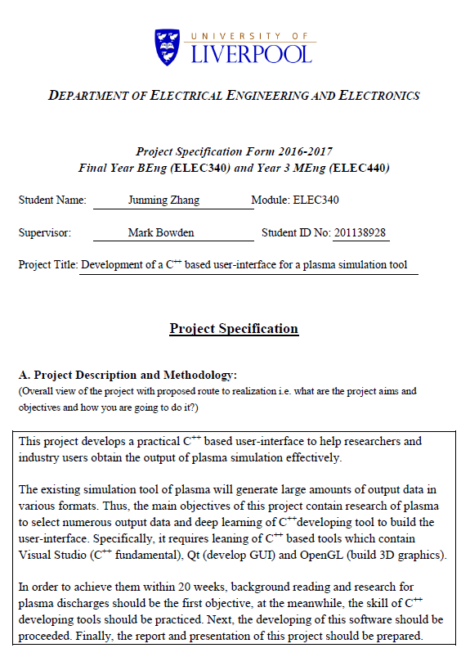

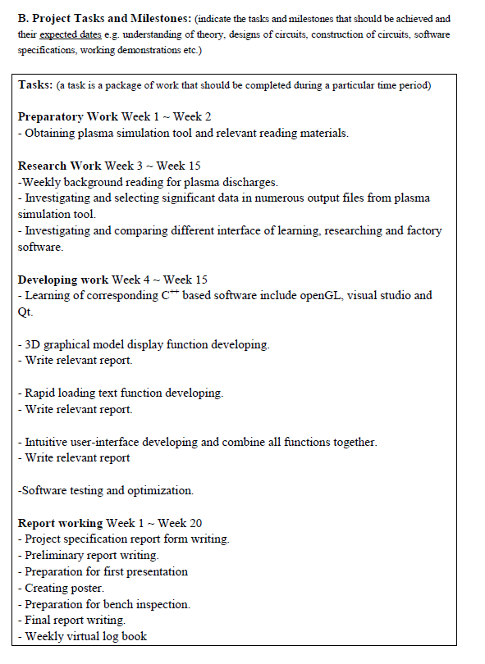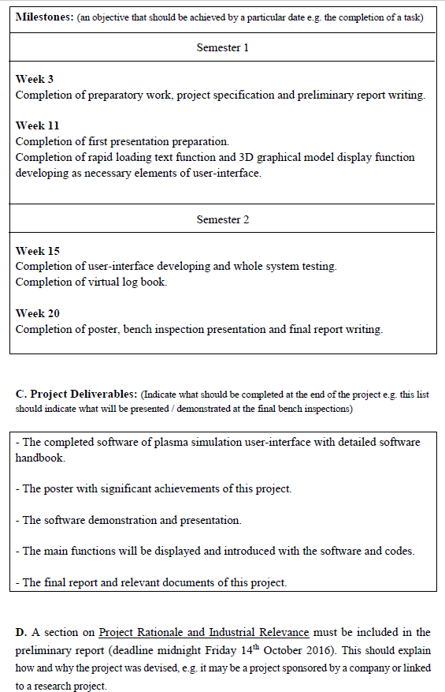

## Appendix 2. A Gantt chart preferable produced by MS project

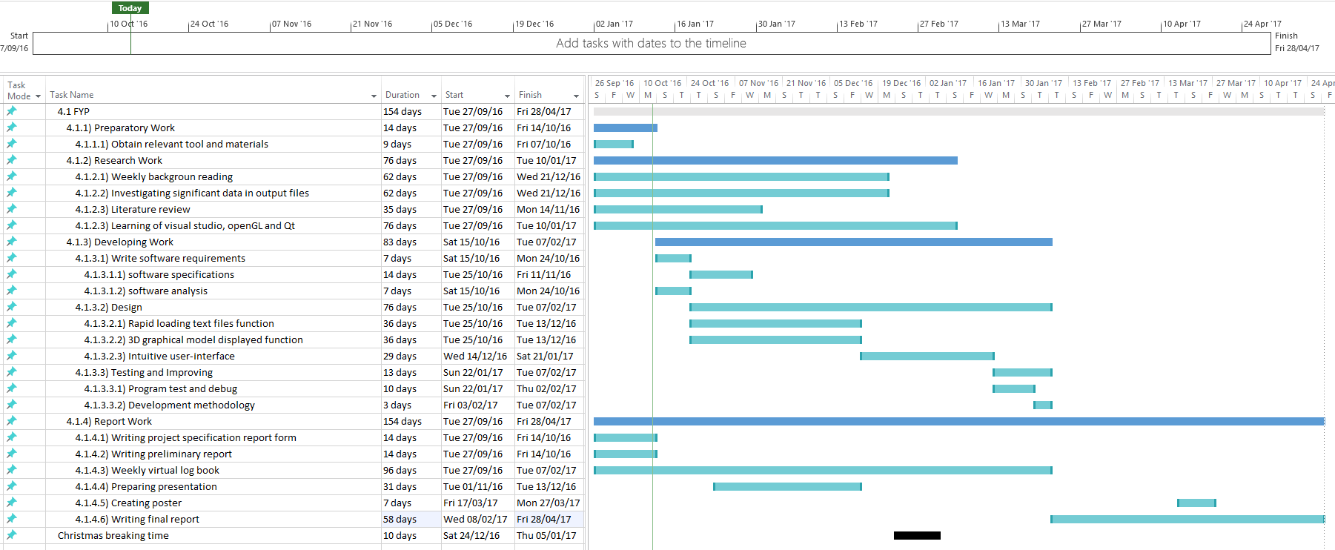

## Appendix 3. The risk assessment form

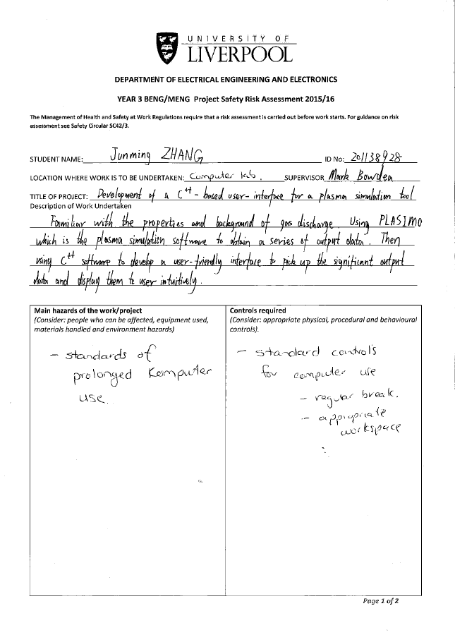

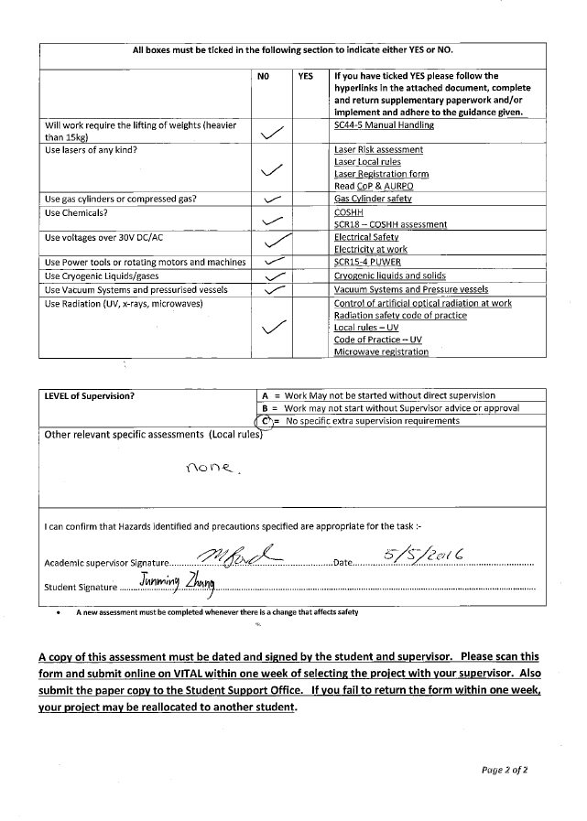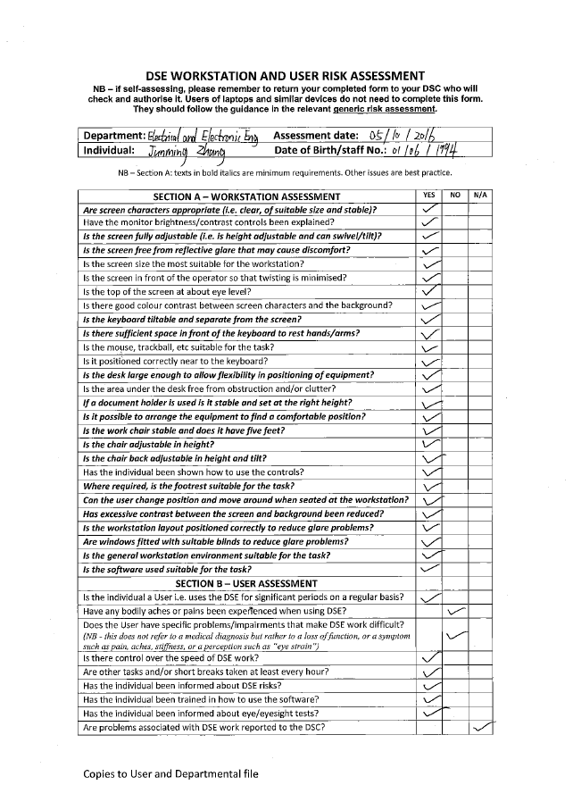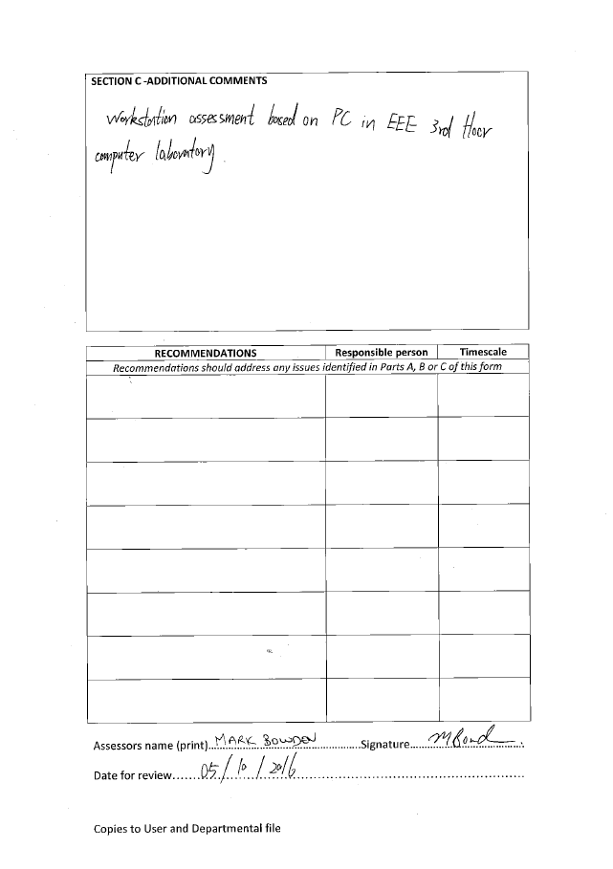

## Appendix 4. Ethical approval questionnaire

